**DAILY ONLINE ACTIVITIES SUMMARY**

|  |  |  |  |  |  |  |  |  |
| --- | --- | --- | --- | --- | --- | --- | --- | --- |
| **Date:** | **07/06/2020** | | | | | **Name:** | **Pratibha Shetti** | |
| **Sem & Sec** | **IV sem & B section** | | | | | **USN:** | **4AL18CS062** | |
| **Online Test Summary** | | | | | | | | |
| **Subject** | | **-** | | | | | | |
| **Max. Marks** | | **30** | | **Score** | | | **-** | |
| **Certification Course Summary** | | | | | | | | |
| **Course** | **Introduction to Cyber Security** | | | | | | | |
| **Certificate Provider** | | | **Greatlearning academy** | | **Duration** | | | **7 hours** |
| **Coding Challenges** | | | | | | | | |
| **Problem Statement1:** Write a C++ Program to swap two numbers using friend as a bridge concept. | | | | | | | | |
| **Status: Executed** | | | | | | | | |
| **Uploaded the report in Github** | | | | | **YES** | | | |
| **If yes Repository name** | | | | | <https://github.com/pratibhashetty-123/Lockdown-coding-java>  <https://github.com/pratibhashetty-123/Lockdown-coding-for-C> | | | |
| **Uploaded the report in slack** | | | | | **YES** | | | |

Online Certification Course Summary: Today I have learnt what is Cyber Security and different types of attacks involved in Cybercrime with this I have completed the course and attempted the quiz after that received the certificate of completion.

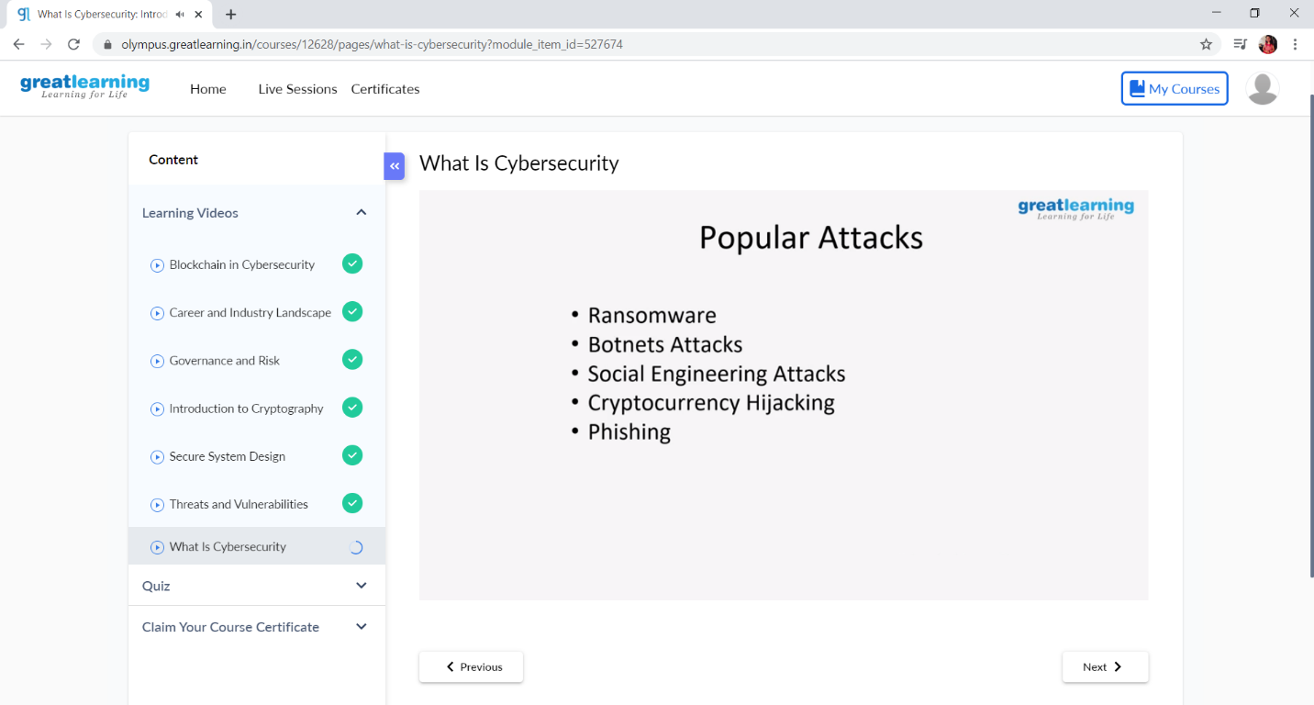

This is the snap shot of today’s session.

Online Coding Summary: **Today I had received one program from prof. Shilpa CSE Dept. The program is mentioned above in the coding challenges(pg.01). I have also uploaded it to my Github repository.**

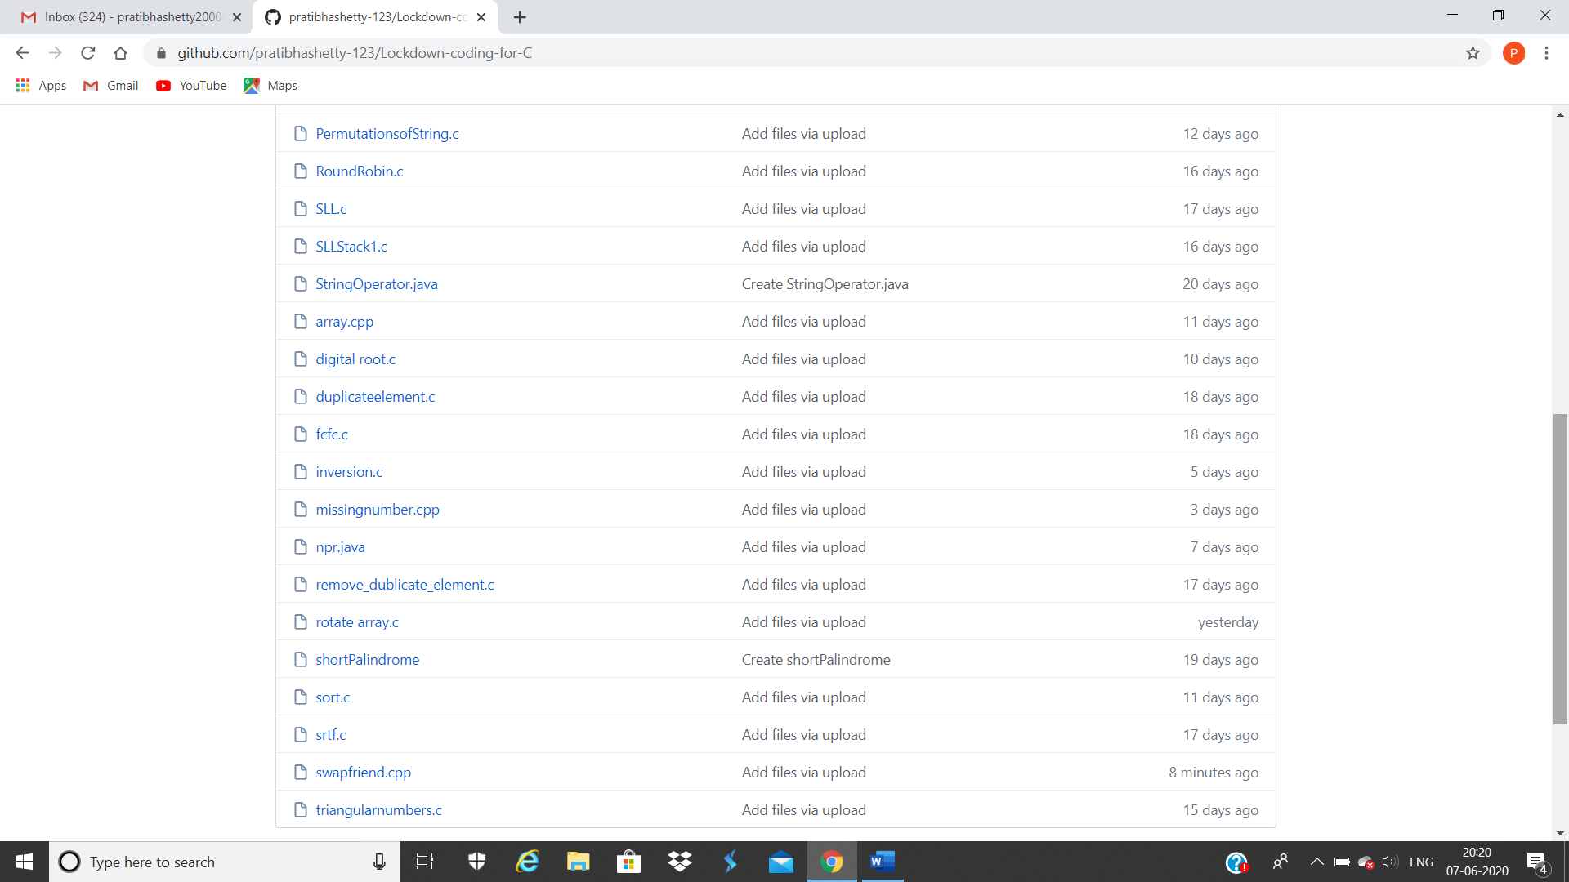

**This is the snap shot of my Github repository** were I have uploaded the code. File name is swapfriend.cpp